Ava Davari

11/3/16

Period 1

ECS Jeroo Project

**Lab Goal:** This lab was designed to help you learn how to work with loops and how to use if and when statements. You have to determine when to command your jeroo to turn to avoid falling into the water, how to get through the maze, and how to stop at the end.

**Lab Description:** This lab requires that you use loops with if statements.You have to get your jeroo through maze to the end without falling into the water. While your jeroo is making its way through the maze it must turn at certain times to avoid falling into the water. Make sure to command your jeroo to stop at the end of the maze to avoid falling into the water.

**Starting Screen:**

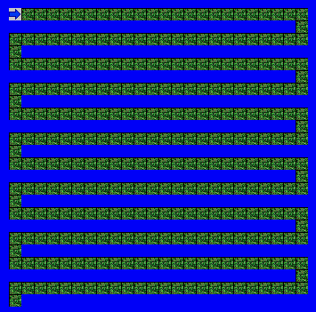

**Ending Screen:**

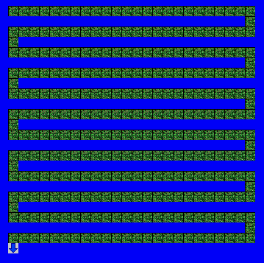

**Files Needed**

jerooproject.jev

jerooproject.jsc

**Algorithm Help**

Preconditions: Postconditions:

Is the path clear to move ahead? Jeroo is not in water

Is there water in front of my jeroo? Jeroo finishes maze

Should I stop? Jeroo stops at end of maze

Should I turn left or right?